
Survey on predators on farmlands for doctoral studies:
“Farming with predators” project
Dear Livestock Producer
I am currently doing research through Stellenbosch University on the size of and possible solutions to farmer conflict with predators in Namibia. A similar survey by the RPO in South Africa showed that farmer lost an estimated R 1 390 453 062,00 annually to predators. Thus, it looks as if current predator management strategies are not really working and alternatives should be considered. Some conservation organizations are of the opinion that farmers exaggerate and that predators are not a major issue. The attached survey is part of the process to determine the real costs of predators on farms and to find practical, long-term and cost-efficient solutions. The more farmers responding, the more reliable the results will be and better solutions could be found. The survey can be filled in anonymously, without mentioning your name or the name of your farm.
For those farmers interested in participating in further research (e.g. collaring the predators on your farm with GPS collars to monitor their behaviour and giving more details on your predator management) or wanting to receive personal feedback on the project, a space is provided for giving your contact details. ALL DATA WILL BE HANDLED AS CONDIFDENTIAL and no details will be published without the express permission of the farmer concerned. The results will be sent to the participating farmers first, before publishing it more widely.
The survey is also available on the Internet for download at http://www.newdevelopment.co.za/FarmingPredator/boere.html or can be filled in online at http://www.surveyface.com/study/Farming-with-predators-survey-9699.php?l=y .
You can send the completed questionnaire to me at: P.O. Box 1755, Otjiwarongo, Namibia. E-mail: chavoux@gmail.com or phone me at 081 312 4678 if there are any questions.
Yours faithfully
Chavoux Luyt
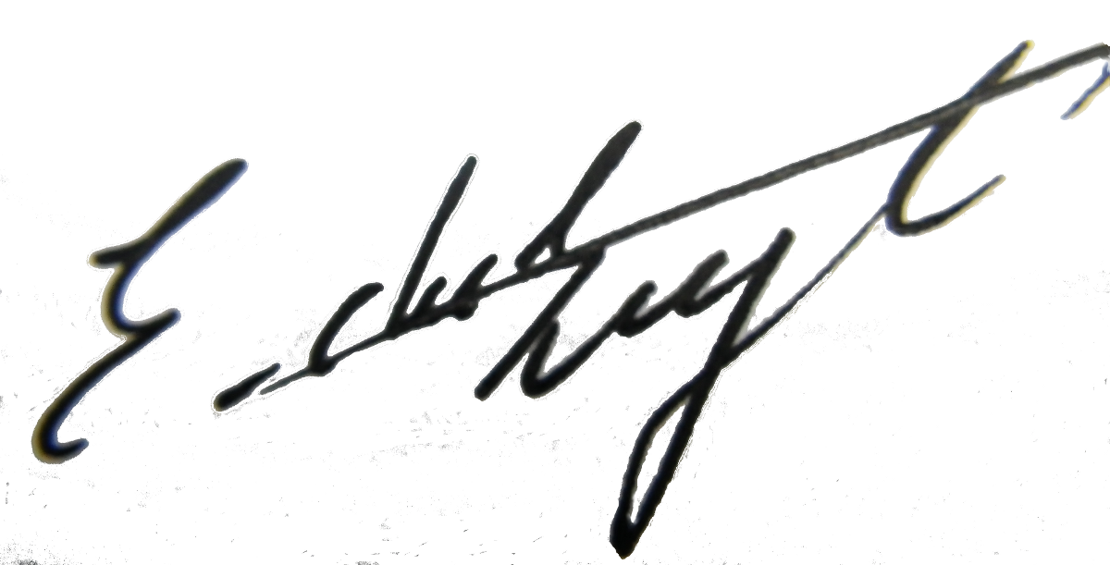
*Contact information (*optional)
*Name (Optional): ___________________________ *Date:______________________________
*Mailing Address: ___________________________ *Farm Name(s):_____________________
___________________________ *Farm Number(s):___________________
*Telephone: ___________________________ *Size of farm (ha):___________________
*Email: ___________________________ *Farmers Association:________________
Do you want to participate in further research? Yes: No:
Farm details (Please fill in everything unless indicated by *– even if just 0 or N/A)
District:_____________________________ How long have you been on the farm (years):_____
Kind of farm - Cattle: Game: Trophy Hunting: Small stock: Mixed:
Size of farm(s) (ha):_______ *How many camps on the farm?: _____________
*Cattle fenced (ha):_____ Game fenced high (ha):______ Game fenced (non-jumping) (ha): ____ Jackal-proof fenced (ha):______ Electrified fenced (ha): _____________
*How many water points on the farm? Permanent:______ Seasonal:______
*Vegetation structure: % Heavy bush:________ % Medium bush:_____ % Sparse bush:__ % Grassland/open:____
* Rainfall(mm):

Are you a member of a conservancy? Yes: No: For how many years?_____________
If yes, does the conservancy function to expectation? Yes: No:
* Conservancy Name: __________________________________________________________
Have you changed or adapted any farm management techniques since joining the conservancy? Yes: No: If yes, what did you change? _____________________________________________________________________________
Livestock and Game details
Livestock numbers: Date of last count ___________________ OR Estimate: Yes: No:
* Changes in livestock numbers (+ Increased; - Decreased; = Stayed the same):

Do you have calving seasons for your cattle? Yes: No:
What time(s) of the year?:_____________________________________________________

Do you have lambing season(s) for your sheep? Yes: No:
What time(s)of the year? _____________________________________________________
Do you have kidding season(s) for your goats? Yes: No:
What time(s)of the year? _____________________________________________________
Do you use small lamb/kid/calf-camps close to house or livestock post? Yes: No:
For which livestock?___________________________________________________________
Do you kraal young lambs/kids/calves during the day? Yes: No:
Which livestock?___________________________________________________________
Do you kraal animals at night (Adult animals too)? Yes: No:
Which livestock? _________________________________________________________
Do you use shepherd dogs (e.g. Anatolian)? Yes: No:
How many and what size? Large ____ Medium___ Small___ Pure bred? Yes: No: Breed(s):________________________________________________________________
Do you use herders? Yes: No:
How many and for which livestock?_________________________________________
Which of the following livestock management methods do you use to help prevent predation losses?
Move livestock to area with few predators: Yes: No:
Use donkeys as livestock guarding animals: Yes: No:
Sell off bad mothers: Yes: No:
Letting horns grow: Yes: No:
Breeds with herding instinct / Large herds: Yes: No:
Breeds with strong protective instinct / indigenous breeds: Yes: No:
How many livestock did you loose in the past year?
Would you be willing to change the breed or type of livestock if it would lead to less predation losses? Definitely: Only if it also has other advantages: No:
Why (not)?_____________________________________________________________________
Any game inside game fenced area? Yes: No:

What kinds of game on the farm and how many of each kind? How did their numbers change over the past 5 years?
* Numbers of Game utilized over the past year: ____________________________________________
Predators and predation losses
Which predators occur on your farm?

*Do you have a predator problem? Yes: No:
Which predator(s)? List:______________________________________________________
*Why do you think you have a predator problem?_______________________________________
Have you lost livestock to predators in the past year? Yes: No:
Have you removed predators from your farm in the past year? Yes: No:
* What management changes have you implemented over the past 5 years that could influence predator numbers?_____________________________________________________________________
* Causing predators to increase or decrease?_________________________________________
* Has there been any management changes on surrounding farms that could influence predator numbers? Yes: No:
* If yes, what changed and what effect did it have on predator numbers? ________________
______________________________________________________________________________
Do you know what the extra costs are of the methods you use to prevent predation? No idea: Estimate: Documented: N$______________________________________________
Would you be willing to change your farming methods if it led to less predation losses?
Yes: No:
Why (not)? _________________________________________________
Why do you prefer your current methods for preventing predation losses?
_____________________________________________________________________________
Do predators have a valute to the farmland ecosystem? Yes: No: What?
Increase biodiversity: Reduce dead carcasses:
Help maintain healthy wildlife: Big predators keeping numbers of other predators in check: Other? _____________________________________________
Do you see solutions to predator problems? Yes: No:

